Team Project: Design Document

For this part of the project you will submit the first version of your game design document. At this stage some of the details could be missing, but you should have a concrete idea you would like to pursue. The purpose of this assignment is to help you conceptualize how your choice of mechanics will produce meaningful play, and to help you tailor your gameplay to target desired aesthetics.

The Design Document

Wilson!!  
McKenna Owens, Logan Hobbs

### Representative Image from the game

### **Provide an initial impression of the visual qualities of the game. This can be a character, scene or item. This could be an image that inspires your art theme or an image from your topic/installation that illustrates the theme**

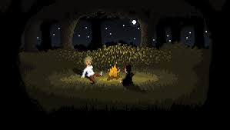

### (Optional) More Representative Images from the game

### **Same as above**

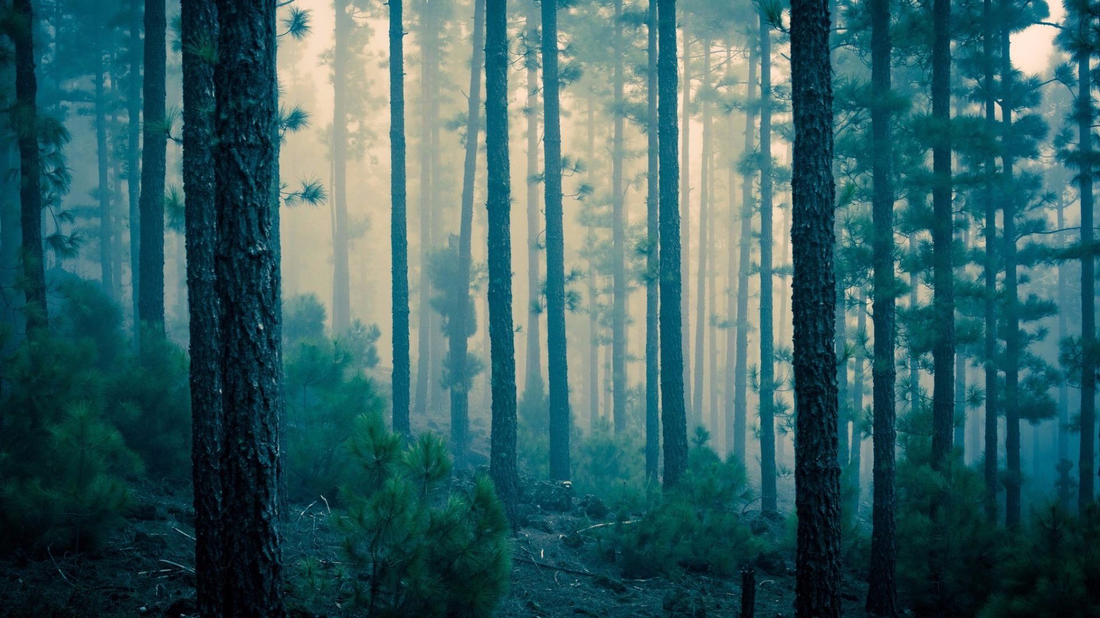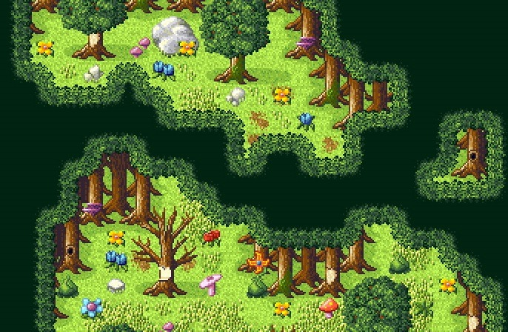

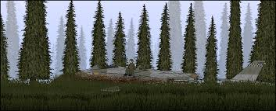 (side scrolling?)

# Executive Summary

### Provide the name of your game

|  |  |
| --- | --- |
| **Title** | Survive the Day |

### Define the Game’s Premise

### **In the textbox below, summarize the premise of the game as you would explain it to a person who has never played it before. Try to use no more than 30 words.**

|  |
| --- |
| Gather supplies to make it to the next day while being hunted by wolves, collecting good resources, and avoiding bad ones to live to the next day (level). |

### Provide the game’s genre and target platform.

|  |  |
| --- | --- |
| **Genre** | Survival/RPG |
| **Target Platform** | PC (puzzleScript) |

## Theme

### Topic

### **What is the topic of your game?**

|  |
| --- |
| The game’s topic is camping/survival. |

### Class theme

### **How does the topic of your game address the class’ theme?**

|  |
| --- |
| The game’s topic addresses the class’ theme of “news making events” as the goal is to survive being stranded. |

## 

## Key Points

### Goal

### **Describe in a sentence what the main goal of the game is.**

|  |
| --- |
| Have the player survive to the next day. |

### Main characters

### **Describe in a sentence the main non-player characters. Optional: include sample artwork.**

|  |
| --- |
| There is a wolf (/wolves) - tracking? -death/restart mechanic?  Saviour - meet at end of game helps you back to society (?) |

### Gameplay flow

### **Describe in a sentence the flow of the game**

|  |
| --- |
| The player collecting all the items and making it to the tent = the next day |

### Player Character

### **Describe in a sentence the main character of the game. Optional: include sample artwork.**

|  |
| --- |
| The player character is rough looking and beat up from living off the land, just trying to make it another day. |

### Player actions

### **Describe in a sentence the actions the player can take in the game.**

|  |
| --- |
| The player can walk and jump with gravity The player can pick up items on the ground.  The player can hide in caves (?)  Sit at tent |

### Uniqueness

### **Describe in a sentence the elements of the game which set it apart from existing games in the same genre.**

|  |
| --- |
| The game is unique because it uses mechanics other than the pushing used in the original game. |

### Important scene

### **Describe in a sentence an important scene from the game. Optional: include sample artwork.**

|  |
| --- |
| An important scene from the game is every scene, because every second of survival is important. |

### Fictional elements

### **Provide the primary fictional elements your game employs.**

|  |
| --- |
| The fictional element is the player surviving the week. We all know there’s no way any of us would survive a week in real life. |

# Game Description

### Background story

### **Provide a detailed description of the fictional background of the game. This should include the plot and setting**

|  |
| --- |
| The year is 2007. Brittney Spears just had her mental breakdown and shaved her head. Trump is not the president. Life is good. [Player Name] decides to go on a road trip to celebrate how amazing 2007 is and nothing, not even something 13 years from now could ruin it. While listening to their favorite country artist, Taylor Swift, their car veers off the road. Everything is a blur. They find themselves stranded in a clearing in the woods, like the one Derek Shepard builds his house on in Grey’s Anatomy. A helicopter flies above writing in the sky “Yo we see you but we’re like kinda busy. We’ll get you in a week lol”. They hear a howl in the distance. The player must survive. |

### Major Characters

### **Describe the major characters in your game, giving detail in what they do and why they exist in the game. Add additional rows to the table to accommodate the characters your game requires.**

|  |  |
| --- | --- |
| **Example Character 1** | This character is an invisible helper character that demonstrates what to do in case of emergencies |
| **The Helicopter Boys** | They help the player out sometimes at random times, they aren’t very useful though, just there for comedic effect and to add to the story |
| **You.** | This is you. You are the player. Life is a simulation. |
| **(Game end Savior)** | Character to “save” you at the end of the game *(WIP) |

### Finishing the game

### **Provide a detailed description of how the player wins the game.**

|  |
| --- |
| The player wins by surviving the wilderness until they escape and get rescued by The Savior. The player has had to collect resources daily (each level) and avoid hangry wolves to finally escape. |

### Key Challenges

### **Describe the challenges you expect the player to overcome in the game.**

|  |  |
| --- | --- |
| **Example Challenge 1** | This challenge involves climbing over a mountain of rocks using nothing but a claw hammer |
| **Your 1st challenge** | This challenge is Avoiding wolves during travel. (pathfinding) |
| **Your 2nd challenge** | This challenge is Avoid collecting bad items. |
| **Your 3rd challenge** | Figuring out how to get to all the berries |
| **Your 4th challenge** | Dodging stalagmites and stalactites. |

### Game Mechanics

**Define the mechanic using the if-then format given in the example below (e.g., how is the player controlled). The boxes below contain words used to describe a previous game, add additional vocabulary to support the description of your game’s mechanics if you need them. Add additional rows to the mechanics table to accommodate your additional mechanics.**

|  |  |  |
| --- | --- | --- |
| **Nouns** | **Verbs** | **Miscellaneous** |
| Player  Box  Switch  Wall  Actor  Directions (north, east, etc.)  Nothing  ... | Move  Stop  Activate  Deactivate  Collide  Appear  Disappear  ... | On  With  In  Of  And  Not  (and so on.)  ... |

|  |  |  |
| --- | --- | --- |
| **Example: Player movement** | **IF:**  An arrow key is pressed on the keyboard | **THEN:**  The player moves in the direction of the arrow key that was pressed, as long as there are no obstacles blocking the way |
| **Picking up Items**  **(implemented)** | **IF:**  Player is over item | **THEN:**  Item is gathered (disappears) |
| **Wolves (pacing)** | **IF:**  Wolf is stationary | **THEN:**  Move direction faced |
| **Wolf attack** | **IF:**  Wolf is next to player | **THEN:**  Player will die (restart) |
| **Wolf Kill** | **IF:**  Player is above Wolf | **THEN:**  Wolf will stop moving  Wolf can not kill Player |
| **Poisoned berries** | **IF:**  Player picks up poisoned berries | **THEN:**  Player will die (restart) |
| **Stalagmites** | **IF:**  Player walks into a stalagmite | **THEN:** Player will die (restart) |
| **Stalactites** | **IF:**  Player walks under a stalactite | **THEN:**  Stalactite will fall  Player will die (restart) if collision |
| **End of Level** | **IF:**  Players are next to tent AND all berries collected | **THEN:**  Level Will End (Continue to next) |

### Fictional aspect advancement (if applicable)

### **Describe how you intend the player to advance the fictional aspects, if possible.**

|  |
| --- |
| The fictional aspects are advanced by ... |

### Levels (if applicable)

### **Describe, if applicable, the game’s levels.**

|  |  |
| --- | --- |
| **Example** | This level contains objects on shelves and tables in a bedroom, for the player to knock on the floor. |
| **Level 1** | (DO WE NEED) |

### Level mechanics (if applicable)

### **Describe, if applicable, which game mechanics are used in each level.**

|  |  |
| --- | --- |
| **Example** | This level utilizes player movement, jumping, and swatting objects. |
| **Level 1** | This level utilizes picking up berries |
| **Level 2** | This level utilizes jumping to get berries and over hills |
| **Level 3** | This level utilizes seeing the wolf for the first time |
| **Level 4** | This level utilizes avoiding poison berries |
| **Level 7** | This level utilizes jumping over stalagmites |
| **Level 8** | This level utilizes avoiding stalactites |
| **Level 9** | This level utilizes using stalactites to climb |
| **Level 11** | This level utilizes all the mechanics |
| **Level 12** | This level utilizes the game finishing |

### 

# Design Goals

### Player experience

### **Describe the ideal player experience for your game.**

|  |
| --- |
| The ideal player experience is to be challenged and contemplate rage quitting 75% of the time, but eventually reach the end of the game with ease and feel content with the journey behind you. |

### Gameplay experience

### **Describe how you expect your mechanics to affect gameplay experience for the player.**

|  |  |
| --- | --- |
| **Example: Player movement** | This allows the player to move around the virtual world, permitting them to interact with the world in places other than their starting location |
| **Picking up Items** | This mechanic allows the Player to gather items used for surviving the day. They must be collected to end the level. |
| **Wolves** | This mechanic adds challenge to the levels by restricting where the Player can move, and when. |
| **Poisoned berries** | This mechanic adds challenge to some levels by requiring the Player to think carefully before planning out a route to take. |
| **Stalactites** | This mechanic adds challenge by having the players time movements to both avoid dying and placing the stalactites. |
| **Stalagmites** | This mechanic requires the player to navigate over stalagmites to avoid death. |

### Educational goal (if applicable)

### **If the game has an educational goal, provide justification that the design facilitates that education goal.**

|  |
| --- |
| The educational goal is to teach players how NOT to properly survive in the woods. (Warning: do not use this game as a survival guide. The developers of this game are not responsible for any persons mauled by wolves or poisoned by berries.) |

### Specific audience (if applicable)

### **If the game targets a specific audience, describe what about the game or mechanics target that specific audience.**

|  |
| --- |
| The design targets are escapists and ambitious. The game draws you in with a challenging premise to survive the days leading up to your recovery. The mechanics have tricks and require keen eyes to spot differences between good and bad. |

# Platform and Tool Justification

### **Up to half a page of justification of your choice of platform and tools. Justification contains information such as support for the type of game that you are designing in terms of examples or availability of tutorials for games similar to yours.**

we don't want to use puzzlescript please god don't make us use it

# Policy on Artwork

Note that we expect all artwork used in the game to be either original, or have license terms that permit non-commercial use. Any artwork that is not properly attributed to external sources (non-team members) will be considered original art. If we find that external sources are used without attribution and permission then we will consider it as a case of plagiarism.

# Deliverables

As a group, you will submit a single file in Word or PDF format.

# Grading Rubric

|  |  |
| --- | --- |
| **Grade** | **Criteria** |
| A+ | Your document meets all the requirements for an A and goes above and beyond, as judged by the instructor. |
| A | Design of the game is innovative in the selection of topic, relation to the theme, and is properly scoped for the submission deadline for the final submission of the project. Includes original and well thought-out references to the culture surrounding the theme. Includes all requested information in the correct format and sufficient detail. Provides references to artwork and all other content sources. Includes excellent justification with examples or clear links to resources available for the platform of choice. |
| B | Design of the game is compelling and the selection of topic, relation to the theme, and scope is clearly indicated. Includes appropriate references and inspirations. Includes all requested information in the correct format and sufficient detail. Provides references to all content. |
| C | Design of the game is clearly presented in terms of selection of topic, relation to the theme is clearly stated, game is properly scoped. Includes almost all the information and is in correct format. Provides references to all external content. |
| D | Lacks detail and doesn't clearly communicate design, connection to theme, and scope. References to theme are not well documented. Document is not in the correct format. |
| F | Not related to theme. Lacks details of design. Does not follow format. |